Essential Companion Scheme
For Organisations

Details of Organisation

Name: _______________________________

Status:
Charity ( )
Local / Health Authority ( )
Private ( )

Name of main contact:
Surname: _____________________________
Address: _____________________________
______________________________________
Town: ________________________________
Postcode: ____________________________
Tel No: _______________________________
Email: ________________________________

Which of the following requirements would you like us to record to you assist in future bookings:

Aisle Seat [ ] Wheelchair Space [ ]
Induction Loop [ ] Other [ ]

www.thelights.org.uk

The group/organisation representative is required to sign this declaration that the group/organisation members concerned are restricted in their ability to access the services and facilities provided at The Lights without assistance, within the scope of the Disability Discrimination Act 1995.

Signed: _______________________________

Print Name (if representative)

_______________________________________

Date: _______________________________

The small print:

*The Disability Discrimination Act 1995 – A person has a disability if he or she has a physical or mental impairment, which has a substantial and long-term adverse effect on his or her ability to carry out normal day-to-day activities. Please note that a false application could lead to civil proceedings and/or prosecution for offences under the Theft Act 1968. All tickets are subject to availability at the time of booking. The theatre reserves the right to review the availability of tickets within the scheme, to review a member’s eligibility and to revoke that membership following review.

If sufficient information is not provided as evidence of eligibility, benefits of the scheme may not be available. We reserve the right to withdraw or amend the scheme at any time.

The scheme will be reviewed every two years.

Essential Companion
Scheme



For Organisations


Scheme for Organisations

The Lights operates a membership scheme for essential companions which will help when booking for groups who need to bring carer/s with them to The Lights.

For the purposes of this document and theatre policy, this person / assistant will be known as an ‘Essential Companion’.

- The membership scheme is not for those who simply require a companion / friend or require assistance with transportation to the venue.

- The ‘Essential Companion’ is somebody who is able to help the person/group with a disability with their mobility or provide guidance to use and enjoy the venue’s services, to ensure their safety, wellbeing and enjoyment of their visit and of those they come into contact with.

- The ‘Essential Companion’ should familiarise themselves with the layout of the venue and the location of services. They should liaise with staff if the person/group requires assistance and take instructions should there be a need to evacuate the building. The ‘Essential Companion’ is required to attend to

the needs of the person/group at all times whilst on the premises.

The scheme allows members to obtain an additional ticket free of charge for their ‘Essential Companion’.

How to Join

The appointed group representative, should complete the form overleaf and return it to The Lights Box Office.

As The Lights is a publicly funded organisation we require either the appointed representative to sign the declaration that the benefits of membership will be used within the terms set out in this document.

The information you provide will help us to offer a better service for you. There is an opportunity on the form for you to tell us about particular needs or you can include information on a separate sheet if required.

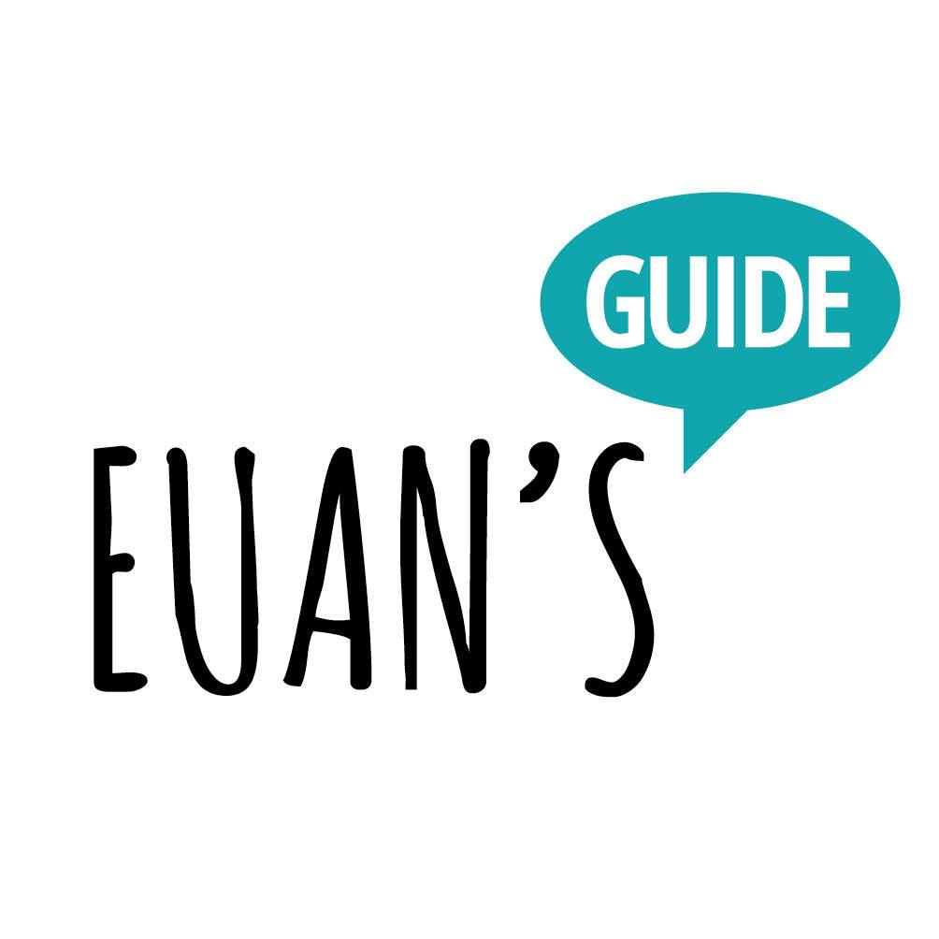
The Lights venue is now listed on Euan’s Guide, a listings and review website that helps disabled people and their families know which venues are truly accessible.

We would love it if you would review us and share your thoughts about your visit to us on Euan’s Guide: www.euansguide.com

General Data Protection Regulations
The information you provide is protected by the General Data Protection Regulations and will only be used for the purpose set out in this document. It will not be shared with any other agency.

The data controller is Test Valley Borough Council (TVBC)
Carole Moore, Data Protection Officer.
Beech Hurst, Weyhill Road, Andover. SP10 3AJ. 01264 368000
You have the right to request access to the information held in addition to the right to rectification and erasure of personal data held about you or restrictions on processing where necessary. You have the right to complain if you feel that your data has been mishandled to the TVBC Data Controller or The Information Commissioner.

