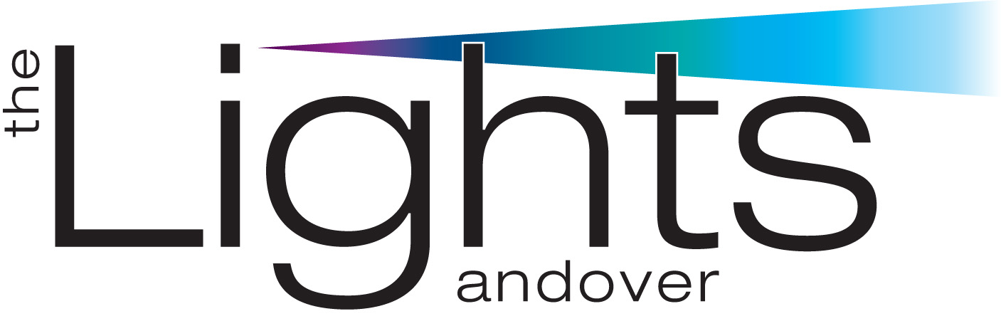
The Lights Technical Guide – June 2022 ver8

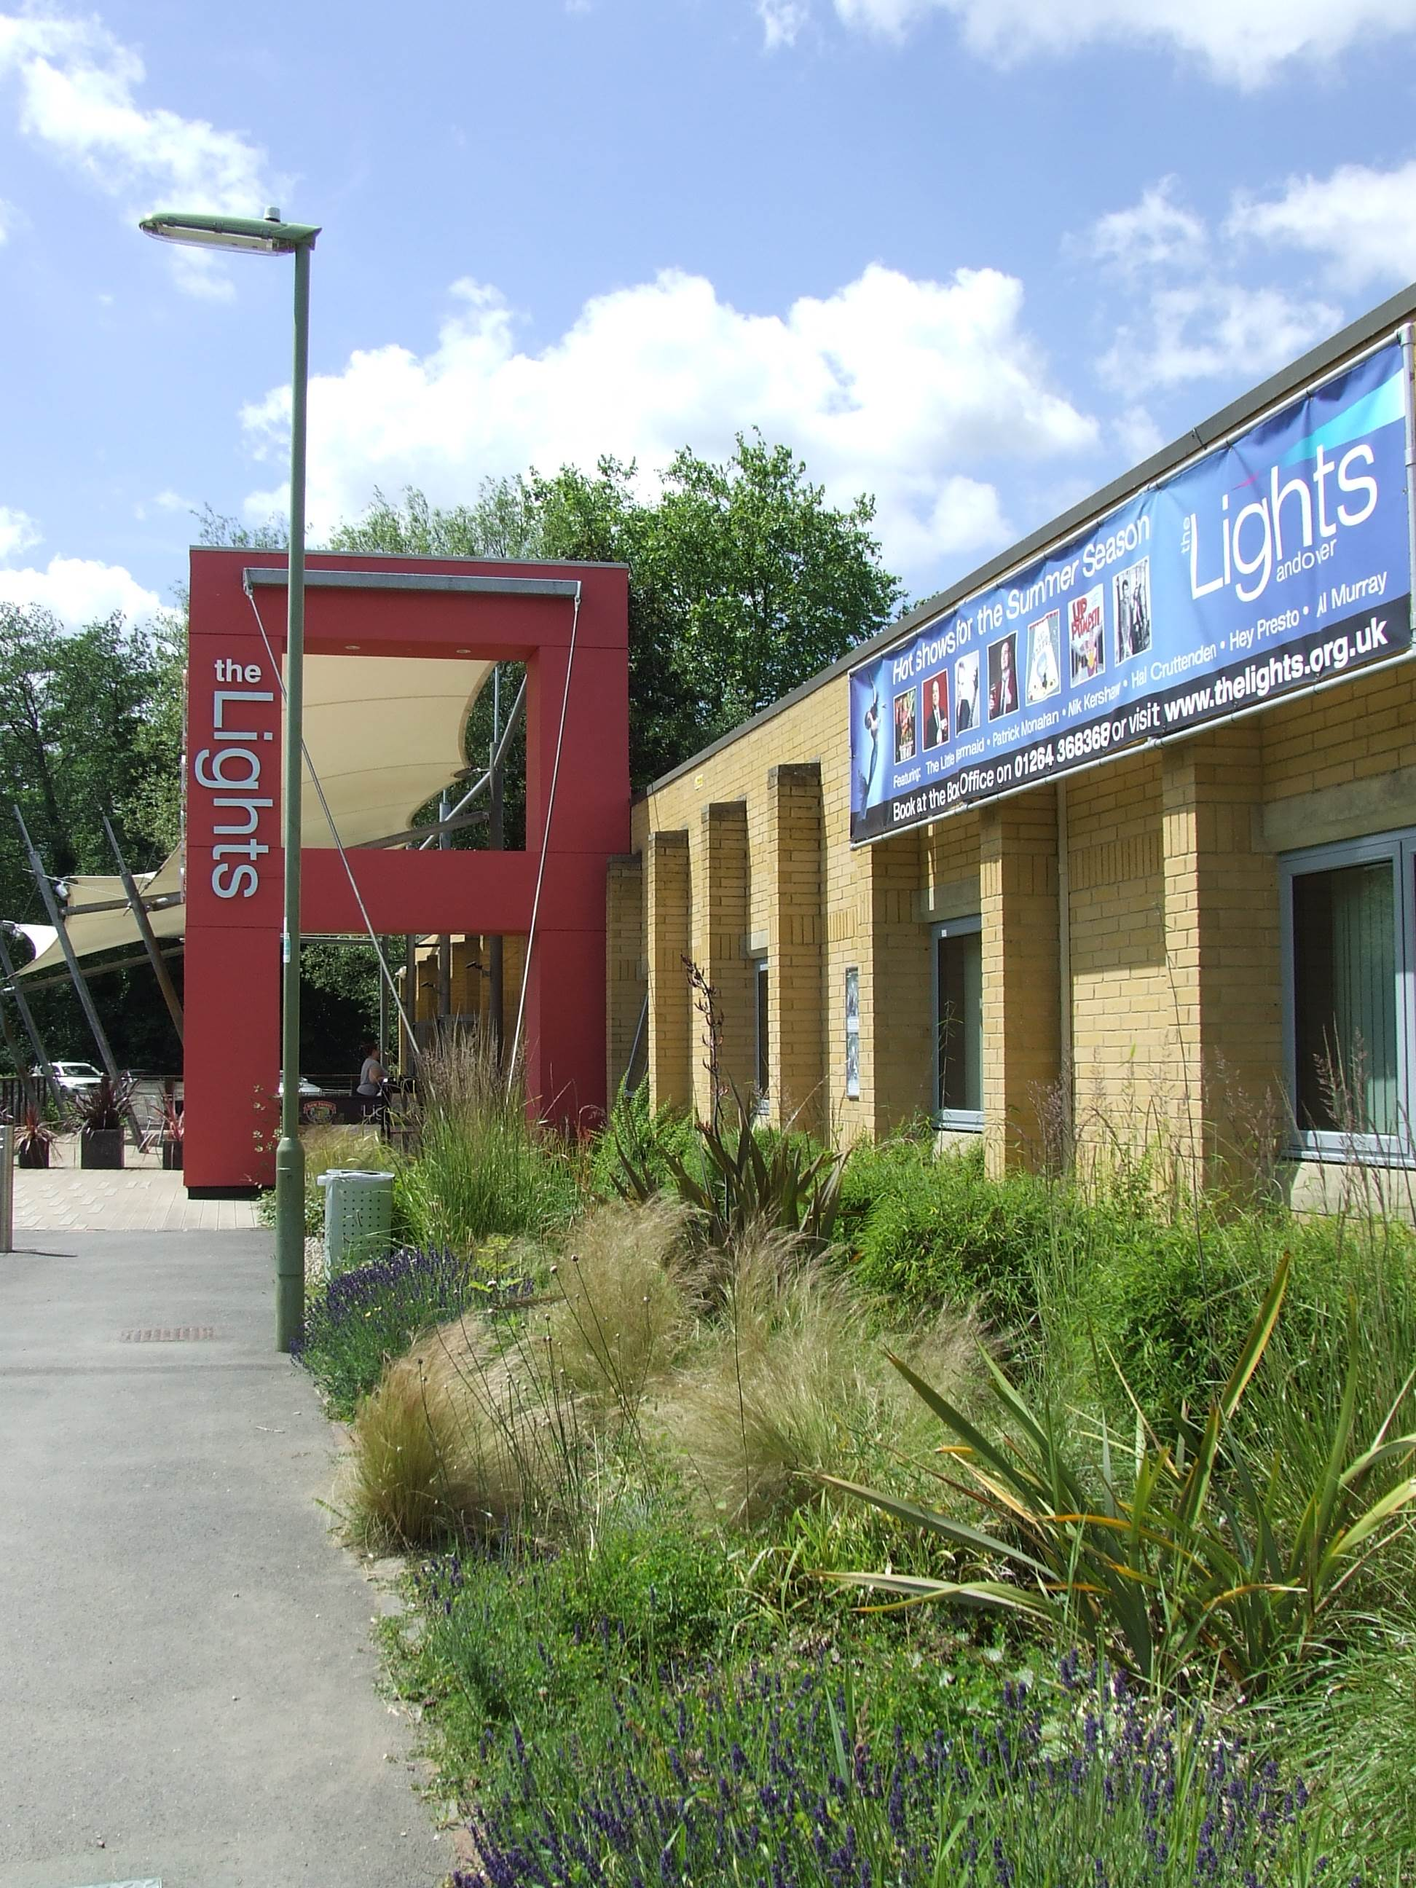
The Lights, West Street, Andover, Hampshire SP10 1AH

01264 368 368 www.thelights.org.uk



The Lights has two performance areas,
the Auditorium and the Arena, both with
their own stage, lighting & sound equipment.

On the following pages you’ll find a wealth of information about The Lights, how to get here, where to park and unload, access and get ins
as well as most of the technical information that you might require.

Should you not find the information
You are seeking please contact us on:

Rob Sewell Operations Manager 01264 368835 rsewell@testvalley.gov.uk

Directions and Parking
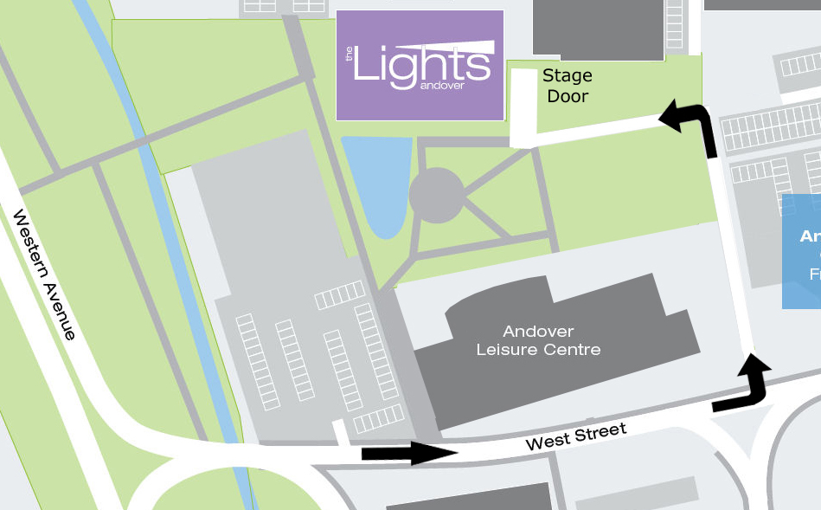
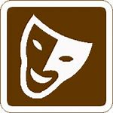
Once in Andover follow the Theatre road signs…
To get to the Stage Door drive down Western Avenue and then turn into West Street.
This is a one way street and the road divides after roughly 100m. Take the first left just after the Leisure Centre and there is a small lane.
Drive down this lane and at the end turn left and the Theatre is ahead of you. The Stage Door is on the right hand side of the Theatre. To gain access, ring the white doorbell on the right-hand side of the Stage Door.
Call us if you are having problems finding us…
Postcode for Stage Door SP10 1QP
What 3 Words romance.tech.heaven

music theatre comedy dance education conferencing

The Lights Andover is owned and managed by Test Valley Borough Council

The Lights Technical Guide 1/8

The Lights Plan view

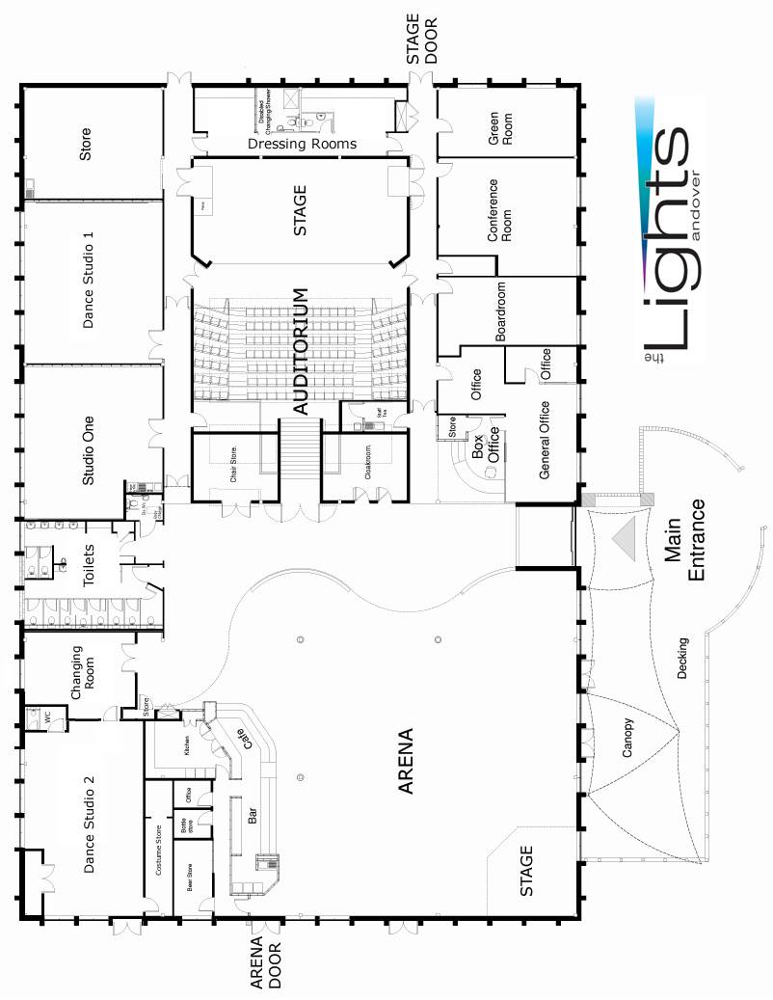

The Lights Technical Guide 2/8

Auditorium Specifications

The Auditorium is in the centre of the building and can be accessed via three sets of double doors
(Main Entrance, Stage Left & Right). There is a Dressing Room and a Green Room behind the Stage.

Stage
The Stage is accessed via the Stage Door (at ground level) and a set of acoustic double doors
which are each 2m high 1.5m wide. The stage itself is 13m wide (internal walls), 6m deep & 0.18m high
The Lighting Grid has eight electric winched bars, four for lighting, four for scenery (2 up stage, 1 stage left and 1 stage right). There is also a 6m x 4m projection screen.
The back wall is white and has black tabs directly in front of it. There are two further sets of black tabs
and three sets of black legs. The blue house tabs are hand winched from stage right.
Power on stage is one off 63amp 1 phase +N+E and one off 63amp 3 phase +N+E.

Seating
The Auditorium seats 249 (of which 33 are ‘Pullman’ style larger seats).
There is ground floor access for up to eight wheelchair users. The seating is fixed and single rake
The Control Box is situated to the rear of the Auditorium.

Lighting
Can be configured to suit most performances but should you require an unusual lighting set-up
please inform us well in advance of arrival.

Dimming: 96 Channels of Dimming (Chilli Pro 24-10i)
3 x CCT Regal 6 pack

Lighting Desk: ETC Element 2

Lanterns: 26 x Source 4 Fresnel
8 x Strand Patt 743 (1kw Fresnel)
4 x Strand Harmony PC (1kw Prism-Convex)
54 x Par 64 Black long nose (1kw, CP62 and CP61)
(10 permanently rigged on FoH booms)
8 x Par 64 Silver short nose, double yoke (1kw, CP61)
5 x Coda 4 CYC LX
8 x CCT Freedom PCs
6 x CCT Freedom 15-32
(permanently rigged on Bridge 2)
2 x CCT Freedom 20-40
2 x CCT Freedom 28-58
8 x CCT 500w Floods
12 x ETC Source 4 16-30
(permanently rigged on Bridge 2)
10 x ETC Source 4 Jr
1 x Mirror Ball (50cm inc motor)

The Lights Technical Guide 3/8

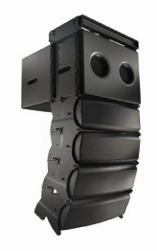
Sound

Sound Desk: Allen & Heath GL2400-32

Amplifiers: 4 x QSC RMX 2450
2 x QSC RMX 5050

Digital Signal Processor: 1 x QSC 322ua Processor

Speakers: 10 x QSC WL2082-I line array modules
2 x QSC WL115-sw line array subs

Monitors: 4 x Studio Spares 15” Wedges

Tie-lines: 2 x 12 tie-line boxes

Playback: 1 x Numark MP-102
1 x Numark CDN 22
1 x Tascam MD350

Microphones and stands: 10 x Shure SM58 microphones
4 x Shure Beta 57A
3 x Shure SM57
1 x Shure Beta 52A
3 x Crown PCC160
2 x Clock Audio C300
1 x Canford Audio C430XB
1 x AKG CGN 99C/S
1 x T-Bone drum kit mic set
10 x Tall boom stands; 8 x Short stands

DI Boxes: 6 x EMO E520
3 x Millennium DIP
2 x DAP Audio StageCube

Radio Microphone: 4 x Sennheiser EW100 G3 radio mic package

Comms: 1 x Tech Pro Master Station
5 x Belt Pack & Headsets

The Lights Technical Guide 4/8

Auditorium and Stage Plan with Stage Bar Positions
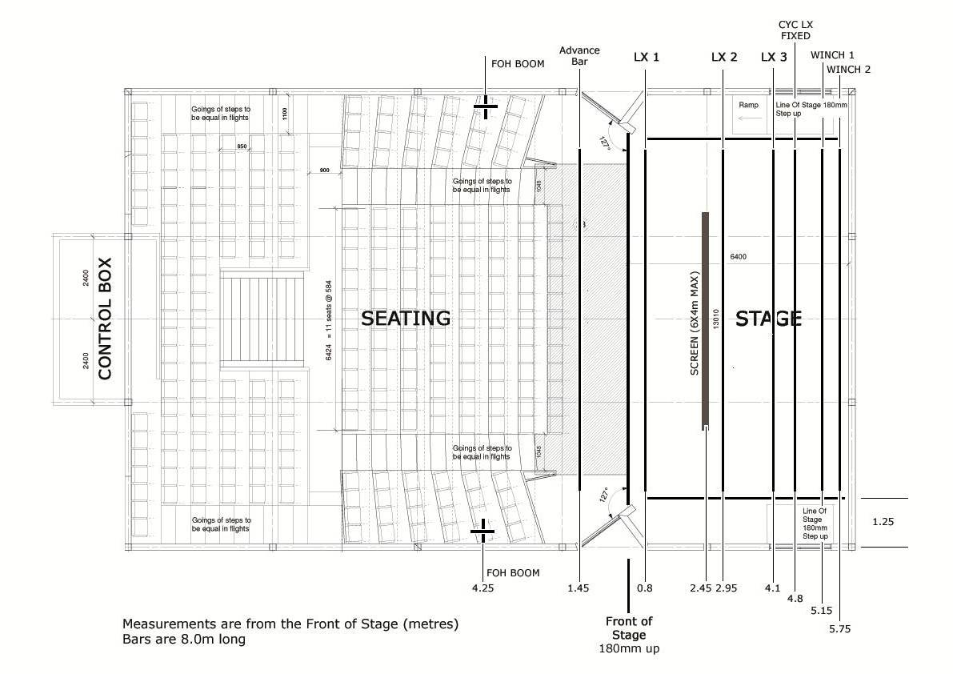
Auditorium Cross Section

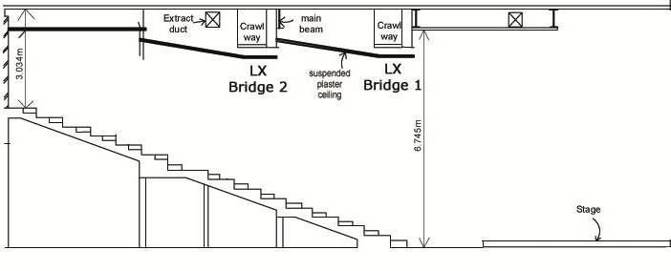

The Lights Technical Guide 5/8

Arena Specifications

The Arena is perfect for large events, comedy or performances in the round, themed exhibitions, or when the lights are changed, a place to relax in a more intimate, cabaret style environment.

The Arena also contains the Bar and the Cafe, as well as an 8m square Pyramidal roof light. Two sets of French doors and full length windows run along the south facing side, exiting directly onto the decking area (175m squared), which is covered by a large canopy. Adjacent to the Arena is the Box Office, Cloakroom and Toilets. The floor is blue carpet, with a vinyl surface under the pyramid. The Arena is a function space for 150-200 seated and roughly 400 standing but can be configured to suit your requirements. To separate the Arena from the foyer there is a ‘moving’ wall allowing for more privacy
for private functions.

The Get-in is via double doors 5m from the stage at ground level, with nearby parking.

Stage
The Stage is 5m wide x 5m deep x 0.5m high, with steps (which are portable).
There is a selection of 13 amp and a 63 amp socket (30+N) on the Stage.

Seating
In the Arena seating is comprised of 50 modular chairs and tables which can be arranged to
suit your event, or removed totally to allow more space.

Lighting
There is a 6m Internally Wired Bar in front of the Stage with ten 500w Par Cans.

Dimming: Anytronics 6way

Lighting Desk: Zero88 Leap Frog

Lanterns: 10 x Silver Par 64 (CP88 500w)
2 x Minuette Fresnel
6 x Generic LED Par
2 x Generic LED Flood

Behind the stage and around the Arena are eight Led wall washers as well as dimmable house lights.
The Pyramid also has perimeter lighting.

Sound
There are two sources of audio in the Arena, a background music system and the main stage system.

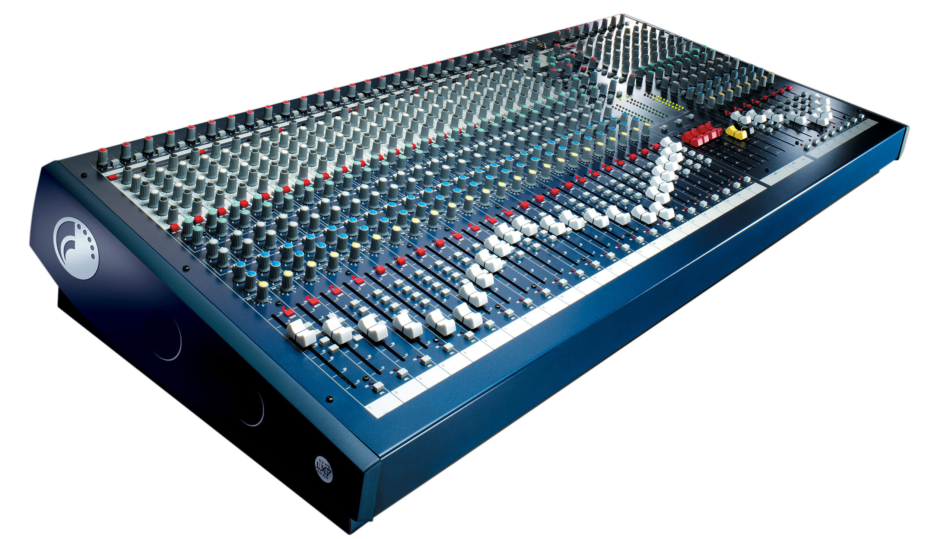
Sound Desk: Soundcraft 24/32 LX-7ii desk
Amplifiers: 2 x QSC RMX 1850
2 x QSC RMX 2450
Digital Signal Processor: 1 x BSS 3088LL Processor
Speakers: 2 x JBL JRX125
1 x JBL JRX118
6 x JBL Control 28’s infill speakers.
Monitors: 3 x JBL EON 1500 speakers
Microphones and stands: equipment shared with auditorium

The Lights Technical Guide 6/8

Arena and Stage Plan View

The Arena measures 18m from the Bar to the Stage wall and 20m across.

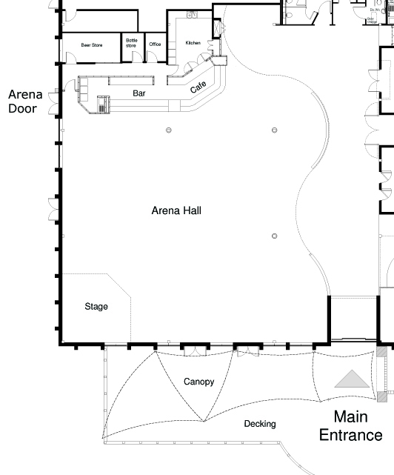

The Lights Technical Guide 7/8

Dressing Room / Green Room / Stage Door / Equipment

Behind our Auditorium are the Dressing Room and the Green Room.

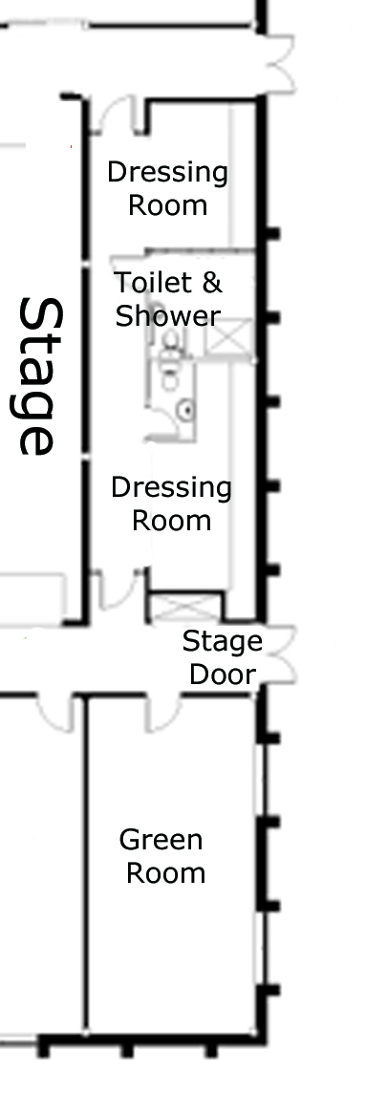
The Dressing Room has two parts with a Toilet and a Toilet / Shower
between them and is fully DDA compliant. There are lit mirrors in both parts, an iron and ironing board as well as three clothes rails.

Seating is provided for 12.

If required the Dressing Room doors can be propped open allowing
access to Stage Left or Stage Right.

In the Green Room we have three sofas around a coffee table, mirrors and tables and chairs. Also provided are a fridge, microwave and kettle.

In both the Dressing Room and Green Room we have an adjustable
relay system to the Stage.

There is Reserved Parking at Stage Door for up to six cars / four vans which is under 24 hour CCTV coverage for security.

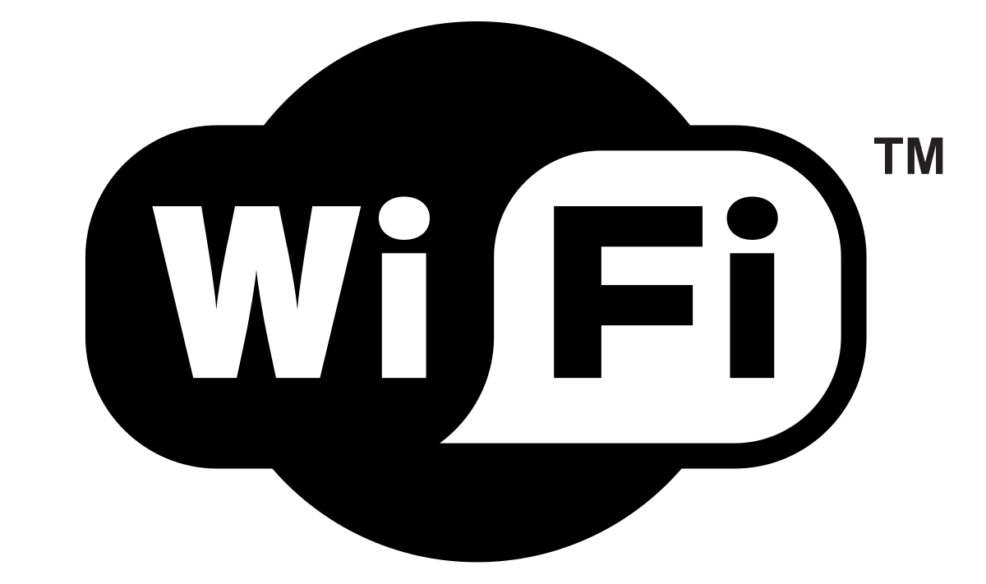
Superfast Wi-Fi (30-36Mbs) is available throughout
the Venue, search for The Lights and just connect,
there is no password.

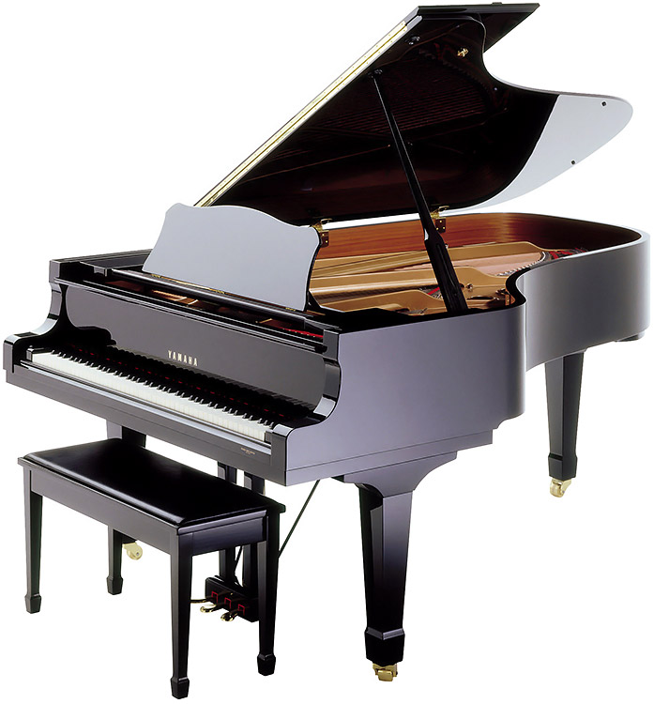
A Yamaha C7 Piano is available to hire if required but we will need notification of this several weeks before your hiring in order to organise tuning.

Other items which are available are a Mirrorball, a Haze machine and also a Projector.

Please note that the Venue is NON-SMOKING throughout including E-Cigarettes, however there is an ashtray situated outside the
Stage Door.

Should you require any other equipment not listed on these pages
please inform our Technical Officer Ricky da Fonseca in advance on
01264 368832 or email rdafonseca@testvalley.gov.uk

The Lights Technical Guide 8/8

